Software Requirements Specification

For Project

Employee Management System

|  |  |
| --- | --- |
| **Prepared by:**  **Deepak Verma**  **Nishtha Gehlot** | **Guide:**  **Shirish Nagar**  **Mentor** |
| **Department of Computer science and engineering,**  **Jodhpur Institute of Engineering Technology**  **16/6/2021 Session – 2019-20** | |
|  | |

**Table of Contents**

|  |  |
| --- | --- |
| **Table of Contents** | Page No. |
| **1. Introduction** | 4 |
| **1.1 Purpose** | 4-5 |
| **1.2 Feasibility** | 5-6 |
| **2. Functional /Non Functional Requirements** | 6 |
| **2.1 Functional Requirement** | 6-7 |
| **2.2 Nonfunctional Requirements** | 7-8 |
| **2.3 Technical Requirements ( Hardware /Software)** | 8-9 |
| **3. System Features** | **9-10** |
| **4. Analysis Diagrams** | 10-12 |
| **4.1 Use Case Diagram**  **4.2 Sequence Diagram**  **4.3 Component diagram**  **4.4 Data Flow Diagram(Optional)**  **4.5 ER Diagram**  **4.6 Activity Diagram**  **4.7 Project Schedule Diagram** |  |
| **5. Glossary** | 12 |
| **6. References** | 12-13 |

**Revision History**

|  |  |  |  |
| --- | --- | --- | --- |
| **Name** | **Date** | **Reason For Changes** | **Version** |
|  |  |  |  |
|  |  |  |  |
|  |  |  |  |

# 

# 

# 

# 

# 

# 

# 

# 

# 

# 

# 

# 1.Introduction

## 1.1 Purpose

#### 1. Improves Collaboration and Coordination

One of the biggest benefits of a task management tool is it improves collaboration between various intra & inter-departmental teams that work to accomplish a common task. Whether the project is large or small, every team member has got a particular role and responsibility. For a smooth execution & timely deployment of the project, it is imperative to ensure that every member remains internally connected.

A task management tool keeps everyone in loop and enhances collaboration. Team members can easily share their questions or status updates with the right person to get help immediately

The [task management software](https://www.taskopad.com/) also enables the team to share files, documents, and keep everyone in the loop.

#### 2. Enhances Planning and Execution

Planning is essential to save time and effort. For every project development cycle, project planning plays a vital role. The project management software can enable managers to assign tasks to different team members as per their skills and execute the project in a proper way. Project planning needs a lot of time as the team has to outline all the major steps. The task management tool enables the management to determine the order of tasks.

#### 3. Facilitates Resource Allocation

The management finds it difficult to allocate resources as per the complexity of tasks and capabilities of resources. It is necessary to manage resources efficiently to ensure smooth accomplishments of business processes. The task management tool also assists the enterprises to define materials, resources, & tools. It is necessary for running a project life cycle seamlessly. An ideal project management tool can also enable companies to hire unnecessary resources that further save overheads & increase ROI over the period.

#### 4. Strengthens Team Workflow

The company can leverage the benefit of a strong team workflow & accomplish all the goals on timeKeeping the entire team in a loop is quite a task, but the task management tool makes it simple. The tool can act as a platform that brings every team member s.together and makes them work together. The project manager can easily track the activities of various team members and check the real-time position of assigned task

It is also possible to find out how much time it will take to complete the task. The [task management app is especially](https://www.taskopad.com/why-choose-us/) useful for the bigger projects as the manager can put various members together for collective work. As a result, .

#### 5. Continuous Monitoring of Tasks

Enterprises need to track the performance of the project at every stage to obtain long-term success and ensure on-time delivery. The task management tool monitors every task to achieve this objective seamlessly. The company management can also fetch performance data of every team member & continuously monitors every stage of the project through this tool. It assists the company to optimize all the projects effectively.

**1.2 Feasibility**

### 1. Technical Feasibility

This assessment focuses on the technical resources available to the organization. It helps organizations determine whether the technical resources meet capacity and whether the technical team is capable of converting the ideas into working systems. Technical feasibility also involves the evaluation of the hardware, software, and other technical requirements of the proposed system. As an exaggerated example, an organization wouldn’t want to try to put Star Trek’s transporters in their building—currently, this project is not technically feasible.

### 2. Economic Feasibility

This assessment typically involves a cost/ benefits analysis of the project, helping organizations determine the viability, cost, and benefits associated with a project before financial resources are allocated. It also serves as an independent project assessment and enhances project credibility—helping decision-makers determine the positive economic benefits to the organization that the proposed project will provide.

### 3. Legal Feasibility

This assessment investigates whether any aspect of the proposed project conflicts with legal requirements like zoning laws, data protection acts or social media laws. Let’s say an organization wants to construct a new office building in a specific location. A feasibility study might reveal the organization’s ideal location isn’t zoned for that type of business. That organization has just saved considerable time and effort by learning that their project was not feasible right from the beginning.

### 4. Operational Feasibility

This assessment involves undertaking a study to analyze and determine whether—and how well—the organization’s needs can be met by completing the project. Operational feasibility studies also examine how a project plan satisfies the requirements identified in the requirements analysis phase of system development.

### 5. Scheduling Feasibility

This assessment is the most important for project success; after all, a project will fail if not completed on time. In scheduling feasibility, an organization estimates how much time the project will take to complete.

## Functional /Non Functional Requirements

## 2.1 Functional Requirements

**REQ-1: Authentication**

1. Login- The user can login to the system with his/her username and password.
2. Logout- The user can log out from the system.
3. Login failure- If the user does not exist in the database or the user has not yet been authorized by the admin.

**REQ-2:Authorization**

1. User role check- After logging in, the user role will be checked from the database and the user interface will be displayed according to their role.

**REQ-3: Employee Management**

1. Display- Users with defined roles can display the content of the database. Being more specific, an employee can only view his/her personal information. Boss can not only see his/her personal information but also employee’s information who are under his/her department or school.
2. Edit- A user with an employee role can edit his/her specific personal information. Boss can only edit employees’ personal information that is under his/her coverage except user role type. Boss can check employee availability.

**REQ-4 :Trainee Management**

1. Training - The Boss and employee shall create training tasks and assign them to other Bosses and employees and employees and trainees respectively that are required to attend the training as well.Boss and Employee can also check the availability of the trainee.

**REQ-5 :Task Management**

1. Tasks - Boss and Employee can check assigned task,they can check task priority.they can also create the task and assign the task

## 2.2 Non functional Requirements

## Performance Requirements

1. There is no restriction on the number of the users to be added to the database.

## Safety Requirements

1. The database may get crashed due to some virus or operating system requirement.Therefore it is necessary to have backup of the database.
2. Inverter facilities should be there in case of power supply failure.

## Security Requirements

1. System will use a secure database.
2. Proper user authentication will be provided.
3. There should be separate accounts of trainee,employee and boss so that the database is not accessed by everyone.

## Software Quality Attributes

1. **Usability**

The system shall allow the users to access the system from the internet using HTML or its derived technologies like CSS.The system uses a web browser as interface as all are familiar with it.It will support English language.

1. **Availability**

The system is available 100% for the user and it is used 24 hours a day and 365 days a year.This system should be operational 24 hours a day and 7 days a week.

1. **Efficiency**

If the system fails the system will recover the backup within an hour or less.

1. **Accuracy**

The system should accurately provide real time information taking into consideration various concurrency issues.The system shall provide 100% access reliability.

1. **Performance**

The information is refreshed at regular intervals depending upon whether some updates have occurred or not.The system shall respond to the member in not less than two seconds from the time of the request submittal.The system should allow it to take more time when doing large processing jobs.

1. **Reliability**

The system has to be 100% reliable due to the importance of data and the damages that can be caused by incorrect or incomplete data.The system will run 24 hour per day,and 7 days a week.

1. **Maintainability and portability**

Changes (password change ,database change)must be verified at least once in a day.The system should provide automatic notification about the overdue,reservation results,availability of reserved items, etc.

## 2.3 Technical Requirements ( Hardware /Software)

**Hardware Requirements :**

1. EMS should be able to work on a computer with the following minimum hardware specifications:
2. OS: Windows XP
3. CPU: Pentium III (700MHz) and above
4. Memory: 128 MB and above
5. Capacity: 4GB of hard drive
6. Others: Network interface card, mouse, keyboard, and monitor.

**Software Requirements :**

Since EMS application is a web-based application, internet connection must be established.

The EMS software personal database model will support the Mysql environment as

DBMS.Technologies used here are VS Code,Github,Git bash,PHP,Software xampp,CSS

and HTML.

# System Features

1. **Sign Up:** Boss,employee and trainee will sign up using their credentials.

stimulus : boss/employee/trainee will sign up through the sign up button.

response : dialogue box for “thank you for sign up” appears.

1. **Log in :** Boss,employee or trainee will login the system using their unique ID.

stimulus : boss/employee/trainee will login through the login button.

response : for boss/employee/trainee different pages will appear respectively.

1. **View employee details :** contains employees’ details.

stimulus : click on button View employee details.

response : Details appear (only boss and employee can view details)

1. **Create Task :** boss can create task to employee or other boss.employee can create task for trainee or other employee.trainee can not create task.

stimulus : click create task button.

response : task will be created

1. **Priority :** Check the assigned task priority.(boss/employee/trainee)

stimulus : click on check assigned task priority.

response : shows priority(High,Medium,Low).

1. **Availability :** check availability of boss/employee/trainee for assigning the task.

stimulus : click on check availability button.

response : shows availability.

1. **Assign Task :** After creating the task the creator will assign the task to boss/employee/trainee.

stimulus : click on button assign task.

response : Task will be assigned

1. **Task Status :** change the task status whether it is completed/submitted/in progress.

stimulus : click on the button change task status.

response : changes will be done according to your status when you choose options from it.

1. **Task done :** The feature indicates the task is done. Only bosses and employees can access this feature.

stimulus: click on the task done button.

response : status will be updated that task is done.

1. **Task Details :** will get trainees through the details of the task assigned.

stimulus : click on View Task Details button

response : details appeared

1. **Personal Details :** will display personal details of the trainee to her /him.

stimulus : click on View personal details button.

response : personal view appear to him/her.

1. **Submit Task :** The feature is for trainees only ,to submit the task.

stimulus : click on submit task button

response : task will be submitted.

# Analysis Diagrams

Use Case Diagram

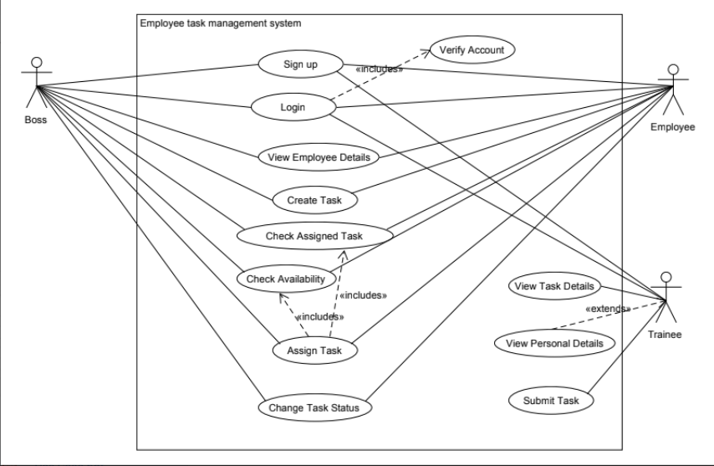

Sequence Diagram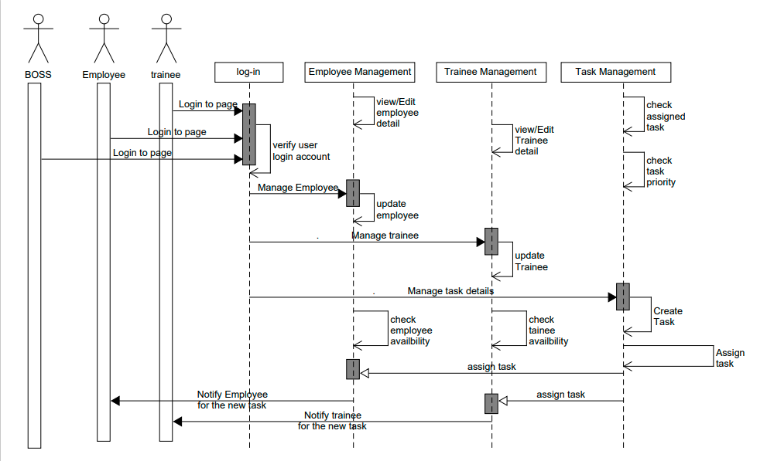

ER Diagram

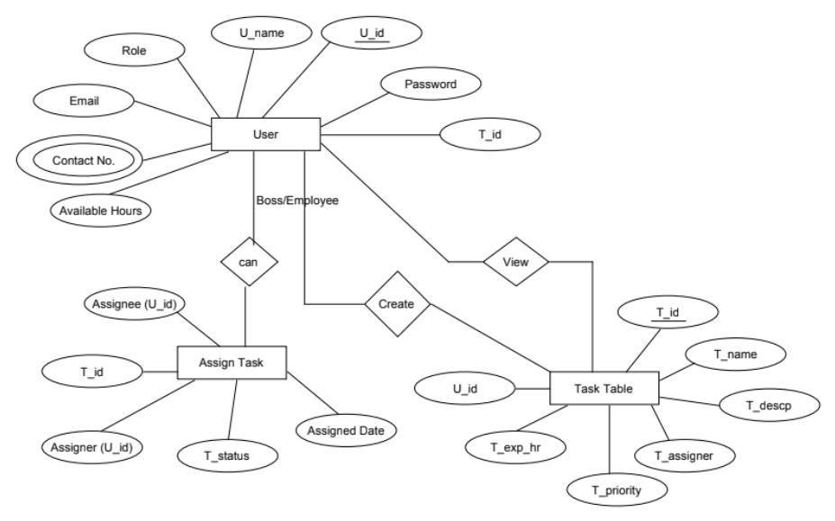

Activity Diagram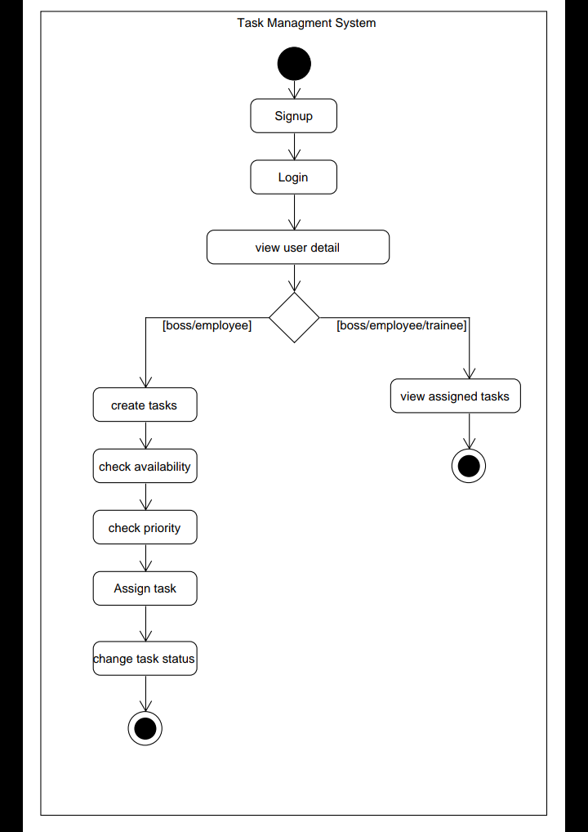

# Glossary

1. EMS : Employee Management Task.
2. CSS : Cascading Style Sheet

# References

[1] OrangeHRM Open Source, Retrieved: November 4, 2013. From: <http://www.orangehrm.com/open-source-product-features-pim.shtml>

[2] Julie Bulmash, “Human Resource Management and Technology”, Chapter 3

[3] ASP.NET, 2010. Retrieved: July 9th 2010, from: <http://www.startvbdotnet.com/aspsite/asp/>

[4] Employee Self Service, Retrieved: January 15, 2014, from: <http://en.wikipedia.org/wiki/Employee_self-service_%28web-based_application%29>

[5] Relevant,Retrieved :January 7, 2019, from: [https://relevant.software/blog/software-requirements-specification-srs-document](https://relevant.software/blog/software-requirements-specification-srs-document/)/

[6] GeeksforGeeks,Retrieved : May 5th 2010,

from: https://www.geeksforgeeks.org/how-to-write-a-good-srs-for-your-project/